

Semester One Examination, 2021

Question/Answer booklet

MATHEMATICS  
APPLICATIONS  
UNIT 3

If required by your examination administrator, please place your student identification label in this box

Section One:  
Calculator-free

|  |  |  |  |  |  |  |  |  |  |  |
| --- | --- | --- | --- | --- | --- | --- | --- | --- | --- | --- |
| WA student number: In figures |  |  |  |  |  |  |  |  |  |  |

In words

Your name

|  |  |
| --- | --- |
| Number of additional answer booklets used (if applicable): |  |

## Time allowed for this section

Reading time before commencing work: five minutes

Working time: fifty minutes

## Materials required/recommended for this section

***To be provided by the supervisor***

This Question/Answer booklet

Formula sheet

***To be provided by the candidate***

Standard items: pens (blue/black preferred), pencils (including coloured), sharpener,  
correction fluid/tape, eraser, ruler, highlighters

Special items: nil

## Important note to candidates

No other items may be taken into the examination room. It is **your** responsibility to ensure that you do not have any unauthorised material. If you have any unauthorised material with you, hand it to the supervisor **before** reading any further.

## Structure of this paper

|  |  |  |  |  |  |
| --- | --- | --- | --- | --- | --- |
| Section | Number of questions available | Number of questions to be answered | Working time (minutes) | Marks available | Percentage of examination |
| Section One: Calculator-free | 8 | 8 | 50 | 51 | 35 |
| Section Two: Calculator-assumed | 13 | 13 | 100 | 98 | 65 |
|  | | |  | **Total** | 100 |

## Instructions to candidates

1. The rules for the conduct of examinations are detailed in the school handbook. Sitting this examination implies that you agree to abide by these rules.

2. Write your answers in this Question/Answer booklet preferably using a blue/black pen.  
Do not use erasable or gel pens.

3. You must be careful to confine your answers to the specific question asked and to follow any instructions that are specific to a particular question.

4. Show all your working clearly. Your working should be in sufficient detail to allow your answers to be checked readily and for marks to be awarded for reasoning. Incorrect answers given without supporting reasoning cannot be allocated any marks. For any question or part question worth more than two marks, valid working or justification is required to receive full marks. If you repeat any question, ensure that you cancel the answer you do not wish to have marked.

5. It is recommended that you do not use pencil, except in diagrams.

6. Supplementary pages for planning/continuing your answers to questions are provided at the end of this Question/Answer booklet. If you use these pages to continue an answer, indicate at the original answer where the answer is continued, i.e. give the page number.

7. The Formula sheet is not to be handed in with your Question/Answer booklet.

Section One: Calculator-free 35% (51 Marks)

This section has**eight** questions. Answer **all** questions. Write your answers in the spaces provided.

Working time: 50 minutes.

Question 1 (6 marks)

A sequence is defined by $T_{n+1}=T_{n}-7, T_{1}=50$.

(a) Write the first six terms of the sequence in the following table. (2 marks)

|  |  |  |  |  |  |  |
| --- | --- | --- | --- | --- | --- | --- |
| $$n$$ | $$1$$ | $$2$$ | $$3$$ | $$4$$ | $$5$$ | $$6$$ |
| $$T_{n}$$ |  |  |  |  |  |  |

(b) Graph the first six terms of the sequence on the axes below. (2 marks)

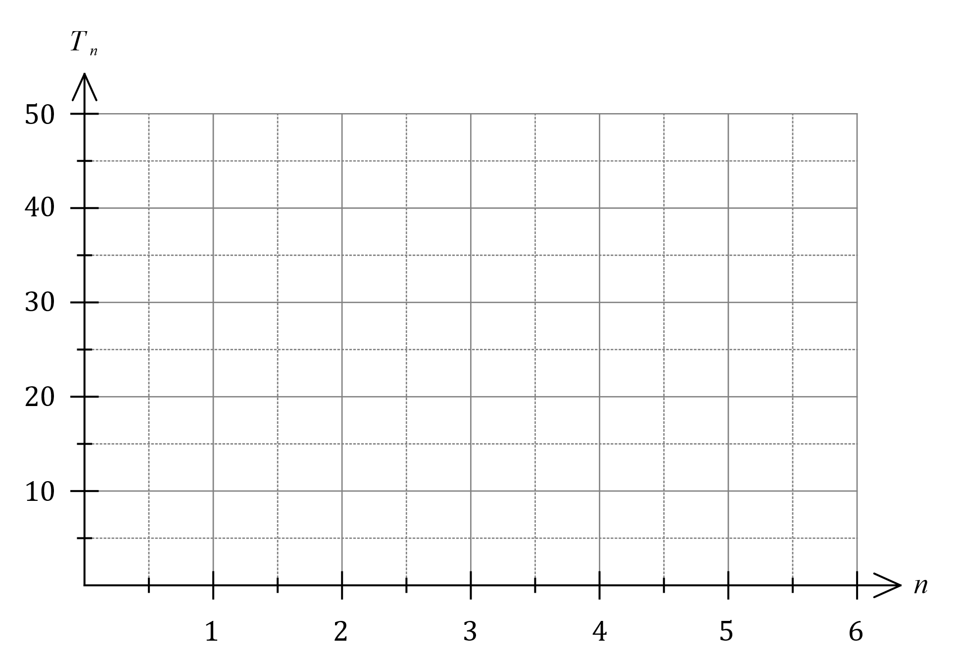

(c) The rule for the $n^{th}$ term of the sequence is $T_{n}=an+b$. Determine the value of the constant $a$ and the value of the constant $b$. (2 marks)

Question 2 (6 marks)

Graph $G$ is shown:

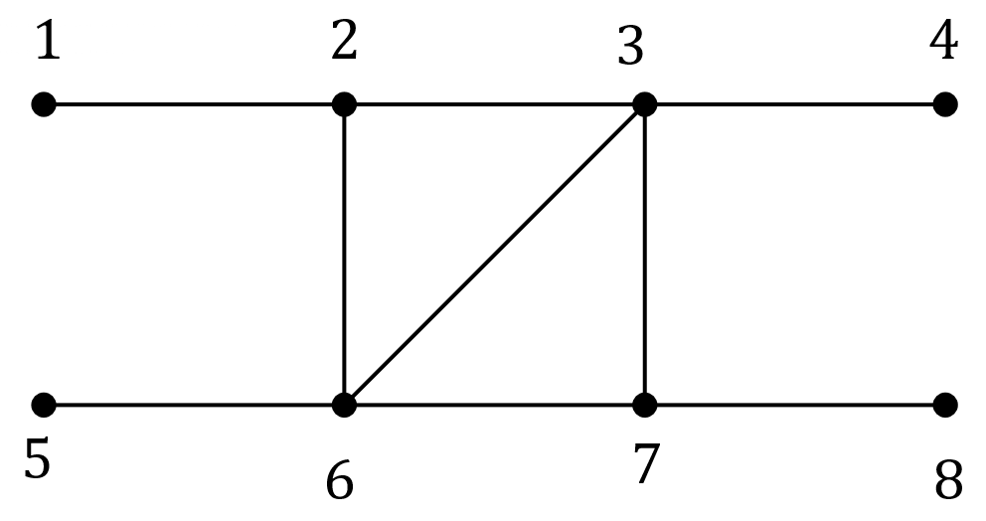

(a) State the number of edges and the number of faces in $G$ and hence show that the graph satisfies Euler's formula. (2 marks)

(b) State the length of the longest trail in $G$ and highlight the edges in a trail of this length on the graph above. (2 marks)

(c) State the length of the longest path in $G$ and highlight the edges in a path of this length on the copy of $G$ below. (2 marks)



Question 3 (6 marks)

A student recorded the time taken and the number of errors made when completing nine multiple choice tests, each with $40$ different questions, in the table below.

|  |  |  |  |  |  |  |  |  |  |
| --- | --- | --- | --- | --- | --- | --- | --- | --- | --- |
| Time, $t$ minutes | $$15$$ | $$22$$ | $$20$$ | $$18$$ | $$11$$ | $$15$$ | $$13$$ | $$6$$ | $$8$$ |
| Number of errors, $e$ | $$8$$ | $$4$$ | $$7$$ | $$10$$ | $$15$$ | $$13$$ | $$9$$ | $$16$$ | $$12$$ |

(a) Construct a scatterplot of this data on the axes below. (2 marks)

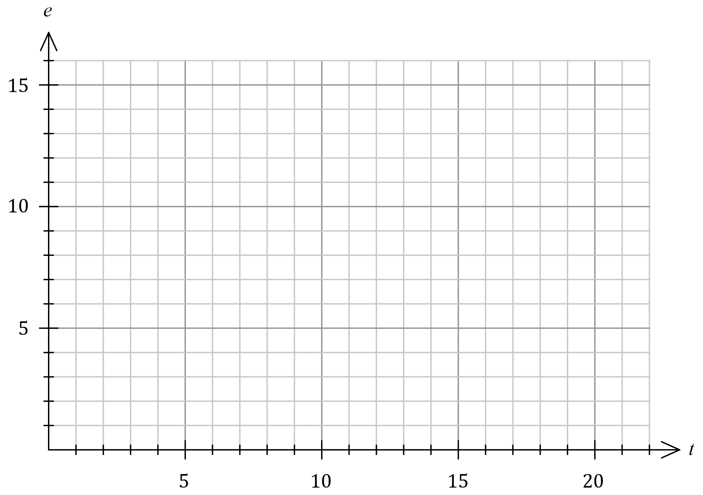

(b) Describe the strength and direction of the association between the two variables.

(2 marks)

(c) The student used the data to conclude that taking more time to answer multiple choice tests caused them to answer more questions correctly. Explain whether this conclusion is justified. (2 marks)

Question 4 (7 marks)

(a) Graph $G$ is shown below. Redraw $G$ in the plane, to clearly show that it is planar.

(1 mark)

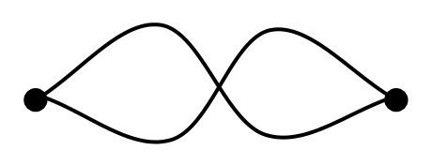

(b) Let $K_{n}$ be the complete graph with $n$ vertices. Draw, and state the number of edges in,

(i) $K_{2}$. (2 marks)

(ii) $K_{6}$. (2 marks)

(c) State, with reasoning, whether $K_{6}$ is a planar graph. (2 marks)

Question 5 (7 marks)

Bivariate data analysis of the mass $M$ g, length $L$ mm and width $W$ mm of a large number of snap peas yielded the following correlation coefficients and least-squares lines:

$$r_{WL}=0.8, L=4W+3, r_{ML}=0.7, L=15M+6.$$

(a) Determine the percentage of the variation in the lengths of these snap peas that can be explained by the variation in their masses. (2 marks)

(b) One of the least-squares lines would be better than the other as a predictor for the lengths of these snap peas. Write the equation of the line below and explain your choice.

(2 marks)

(c) Use the equation from part (b) to predict the length of a snap pea that has a mass of $7$ g and a width of $27$ mm. (1 mark)

(d) (i) Identify one factor that supports the validity of the prediction made in part (c). (1 mark)

(ii) Identify one factor that makes it difficult to comment on the validity of the prediction

made in part (c). (1 mark)

Question 6 (7 marks)

(a) Digraph $G_{1}$ is shown. Complete the adjacency matrix $M$ for $G_{1}$. (2 marks)

|  |  |  |  |
| --- | --- | --- | --- |
| $$M$$ | $$A$$ | $$B$$ | $$C$$ |
| $$A$$ |  |  |  |
| $$B$$ |  |  |  |
| $$C$$ |  |  |  |

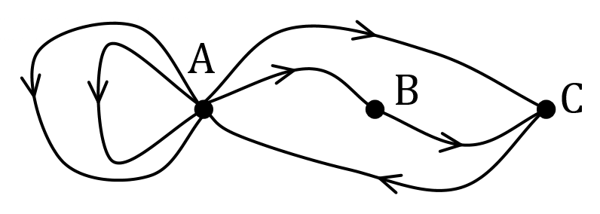

(b) The adjacency matrix $A$ for the non-directed graph $G_{2}$ with $4$ vertices is shown below.

$$A=\left[\begin{matrix}1 & 3 & 1 & 0 \\ 3 & 0 & 1 & 0 \\ 1 & 1 & 0 & 2 \\ 0 & 0 & 2 & 1\end{matrix}\right]$$

(i) $G_{3}$ is a subgraph of $G_{2}$, and has $4$ vertices $.$ State, with reasoning, the minimum number of edges that must be removed from $G_{2}$ so that $G_{3}$ is a simple graph.

(3 marks)

(ii) In the matrix $A^{4},$ the entry $a_{3,2}=68$. Use precise terminology associated with graphs to fully explain the meaning of this entry in $A^{4}$. (2 marks)

Question 7 (6 marks)

The scatterplot below shows data from $25$ samples drawn from different suburbs in a city. The variables are the percentage of people in each sample who have grey hair ($x$) and who have heart disease ($y$).

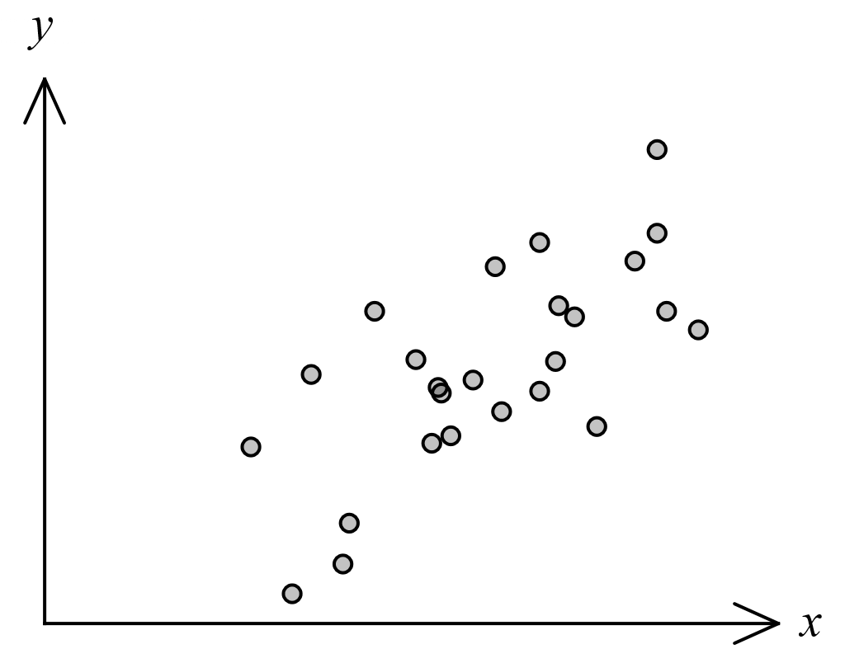

(a) The correlation coefficient $r_{xy}$ for this data is one of $0.7, 0.4 , 0.2, -0.2, -0.4, -0.7$.  
State $r_{xy}$ and explain your choice. (2 marks)

(b) The least-squares line for the data is $y=ax+b$, where $a$ and $b$ are constants.

(i) State the name of the response variable for this least-squares line. (1 mark)

(ii) Explain whether the constant $a$ would be a positive or negative number. (1 mark)

(c) Identify and explain a possible non-causal explanation for the observed association between the variables in this data. (2 marks)

Question 8 (6 marks)

(a) Let $K_{m,n}$ be the complete bipartite graph with $m$ vertices in one set and $n$ vertices in the second set. Draw $K_{2,3}$ and explain whether $K_{2,3}$ is Hamiltonian, semi-Hamiltonian or neither. (3 marks)

(b) The vertices and edges in the graph below represent students and friendships, respectively. Determine whether it is possible for the students to sit in a circle so that every student is sitting between two friends. If it is possible, draw a possible seating plan. If it is not possible, explain why. (3 marks)

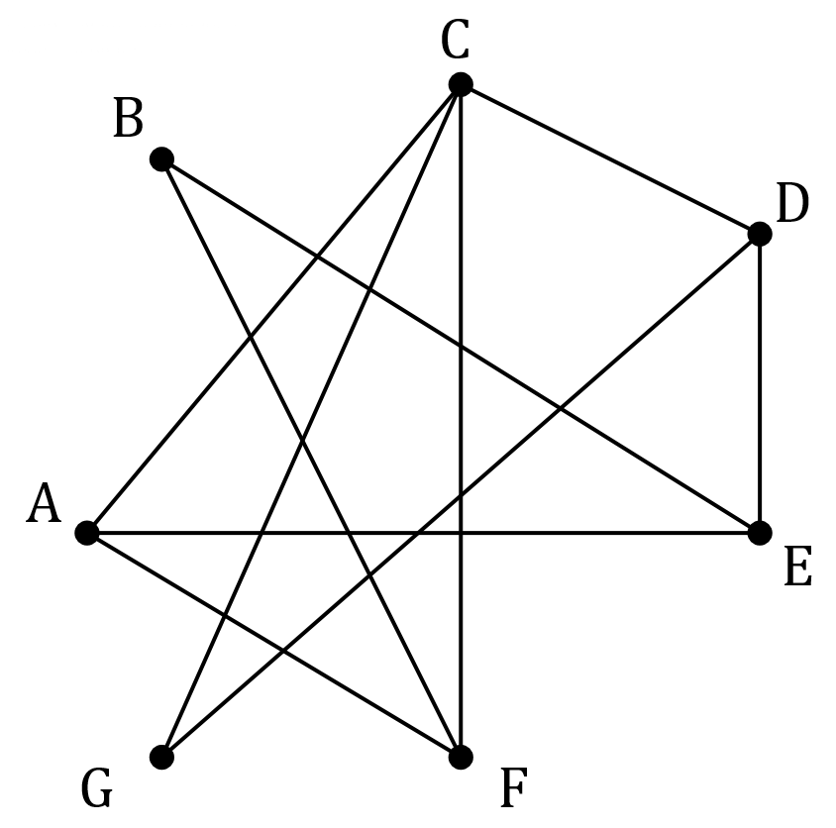

Supplementary page

Question number: _________

© 2021 WA Exam Papers. Mater Dei College has a non-exclusive licence to copy and communicate this document for non-commercial, educational use within the school. No other copying, communication or use is permitted without the express written permission of WA Exam Papers. SN061-176-1.